Ironi “A” High School

Welcome to the 7th grade
If you're joining us next year in the 7th grade, you might want to review some of the material you've learned in English beforehand. Here are some exercises to help you! Have fun!
Nouns
- Singular and Plural Nouns
Complete the sentences with a / an / the
- I have _____________ cookie. _____________ cookie is tasty.
- I have _____________ apple. _____________ apple is red.
- There is _____________ book on the table. _____________ book is interesting.
- She is eating _____________ orange. _____________ orange is delicious.
- They live in _____________ big house. _____________ house is big.
- There is _____________ avocado on the table. _____________ avocado is not *ripe yet.
*ripe = בשל

Write the words in plural
Singular | Plural | Singular | Plural | Singular | Plural
a balloon |  | a brush |  | a fish
a house |  | a glass |  | a sheep
a cake |  | a sandwich |  | a mouse
a cookie |  | a box |  | a child
a boy |  | a wife |  | a man
a city |  | a potato |  | a foot
a party |  | a tomato |  | a tooth

.

Complete the sentences with words from the table in singular or plural.
It's Donna's birthday tomorrow. We need to get ready for her _____________.
We need to bake a _____________ and hang up the _____________. We also need to buy _____________ and two chocolate _______________. The _____________ love candy, but it is not good for their _____________.

- Count/ Non-Count Nouns, Some/ Any
Copy the words from table A to the correct column in table B
A
cake | sugar | carrot | cookie | milk | grape
sandwich | potato | money | banana | rice | oil
meat | soup | water | apple | ice cream | coffee
pasta | popcorn | salad | chicken | candy | juice
B
Count Nouns |  |  | Non-Count Nouns
Complete the sentences with some/any
- Can I have _____________ milk please?
- I don't want _____________ water, thanks.
- May I have _____________ juice please?
- There are _____________ sandwiches in the picnic bag.
- We don't have _____________ bread.
- Do you have _____________ brothers or sisters?
- There is _____________ cake in the fridge.
- I don't need _____________ help, thank you.
Complete the sentences using any /some/a/ an
- Anna bought ____________ clothes.
- Can you give me _______ information about the places we are going to see?
- He didn't have _________ money when he left home.
- He never does __________ work around the house.
- There was ____ man talking to _________ women on the street.
- Anna is looking for _________ job.
- Would you like _________ apple?
- We live in ________ small house.

- Possessive Pronouns

Exercise 1: Match.

Keren it
Ben they
Lee we
the school she
Tom and Anat she
you and I he

Exercise 2: Fill in the following sentences. Use -I, you, he, she, it, we or they. Remember to start with a capital letter.

- Keren is a girl. 4. You and I are friends too.
__________ is my friend. __________ are at school.
- Ben is a boy. 5. This is a ball.
__________ is here. __________ is a football.
- Keren and Ben are friends. 6. __________ am a pupil and
_________ are in the park. __________ are a pupil too.

Exercise 3: Write the correct pronoun.
- Tim is a cat. _________________________________________ .

- Dana and Donna live in Tel Aviv. _________________________.

- My books are new. ____________________________________ .

- Sara and I are in the park. ______________________________ .

- Rina is a teacher. ______________________________________ .
- Pronouns
- Fill in the correct pronoun. ( I, He, She, It, We, You, They)
Limor _________________
Uri _________________
Our dog _________________
My friend ________________
Uri and Yoav ________________
You and I ________________
- Circle the correct item.
She Tom Liat the boys
He the boy the girl the ball
We Tom and Yair Rachel and I the man
They My father and I the house the girls
It mother the park you and I

- Fill in I, you, he, she, it, we or they
1. Yonit is a girl . ______________ is my friend.
2. Roni is a boy. ________________ is here.
3. My friends are here. ______________ are in the park.
4. Shira and her sister are nice. _________________ are at school.
5. This is a desk. __________________ is my desk.
- Review of Tenses
Fill in the blanks with the correct forms of the verbs in brackets.
- I ____________(visit) my grandmother next month.
- The boys ____________(use) the computer now.
- Mrs. Dan _______________(run) three kilometers every morning.
- They ______________(not stay) in the a hotel next summer.
- Irit _____________(not listen) to the teacher at the moment. She is talking.
- Last year I ___________(go) to a wonderful summer camp.
- Ron ______________(not practice ) the piano every day.
- We ____________(meet) our cousins at the airport last night.
- The passengers ______________(not arrive) until 8.00 p.m. last night.
- We ___________(bake) cakes on Fridays.
- ____________ (you /read) yesterday’s newspaper?
- ______________(you/ meet) me tomorrow?
- ____________( the children/ play) at the park at the moment?
- _____________( the baby / drink) milk every day?

- Adjectives-Comparative and Superlative.
- Avi is _________________(tall) than his brother.
- Ronit is _______________(tall) girl in class.
- This is __________________( interesting) book in the library.
- Tali’s room and Dan’s room are the same size. Tali’s room is _______________(big) Dan’s.
- She is ______________(nice) person in the office.
- Ron is _____________(young) than his brother.
- My chair is ______________(comfortable) than yours.
- Mr. Cohen is _________________( young) teacher in the school.

- WH questions
Write wh questions for the following sentences.
- Tal and Amit are going to tidy their room
____________________________________________________?
- The family will return on the 24th of June
____________________________________________________?
- The teacher gives lectures every day.
_____________________________________________________?
- The train left two hours ago from Haifa
_____________________________________________________?
- The postman is delivering the letters today
_____________________________________________________?
- Avi takes Tal and Liat to school.
_____________________________________________________?
- They play in concerts on Saturdays.
_______________________________________________________?

- Modals- Can/ could/ can’t/ couldn’t
Fill in the following blanks with the correct modals.
1.Yesterday was a clear day we _____________ see the mountains.
2. That shelf is too high. I ___________ reach it.
3. Maya ____________play the harmonica and the piano. She is very talented.
4. It is too noisy. I ____________ hear a thing.
5. He missed the bus because he ______________ run fast enough to catch it.
6. He is a terrible dancer. He _____________ dance well at all.

Writing exercise #1:
Look at the picture of Ben's room. It is very messy. Write 5 sentences about his room.
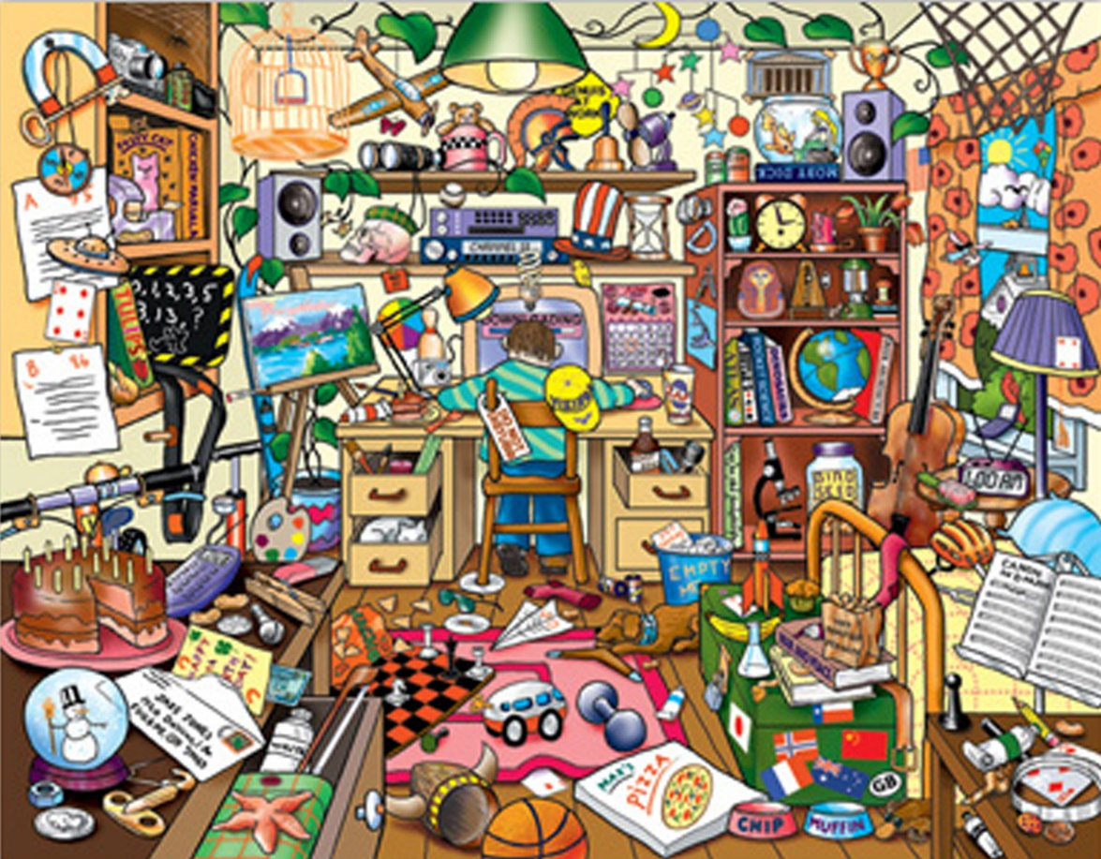
example: There is a chess set on the floor. ____________________________________________________________________________________________________________________________________________________________________________________________________________________________________________________________________________________________________________________________________________________________________________________
What is Ben doing now?
_____________________________________________________________
Writing exercise #2:
Look at the picture of the party. Everyone is having fun. Write 8 sentences about what the teenagers are doing.
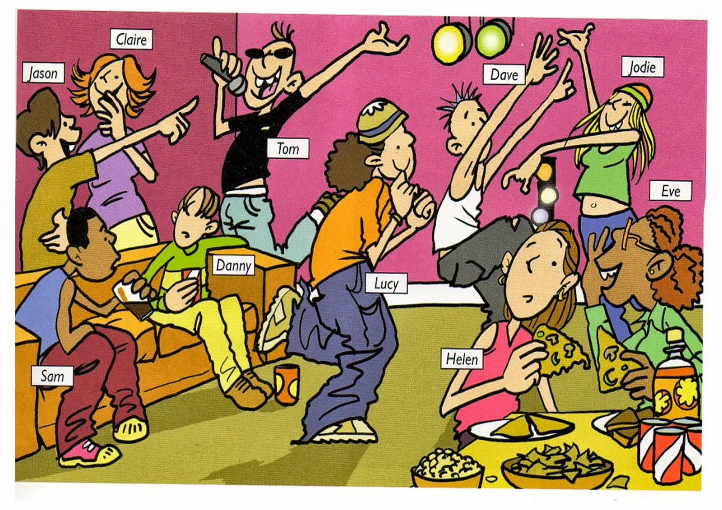
Example: Helen is listening to Eve.
________________________________________________________________________________________________________________________________________________________________________________________________________________________________________________________________________________________________________________________________________________________________________________________________________________________________________________________________________________________________________________
Writing exercise #3:
Look at the picture: "A Busy Day on Main Street". It was painted by Bonnie White.
Write 8 sentences describing the busy day. You can make up your own names.
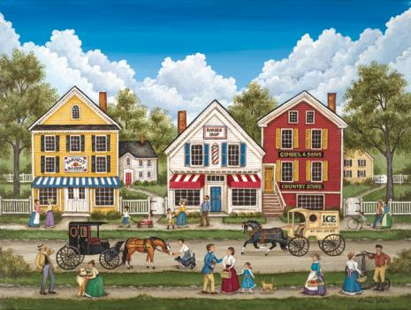
Example: It is a nice day. Mrs. Jones is petting her dog.
__________________________________________________________________________________________________________________________________________________________________________________________________________________________________________________________________________________________________________________________________________________________________________________________________________________________________________________
Don't forget to check your work:
- Did you follow the instructions?
- Did you remember to put a period at the end of each sentence?
- Did you remember to use capital letters correctly?
- Did you check that all your verbs are in the correct tense?
- Is your handwriting neat and clear?
Good job!

- Reading Comprehension- Unseens
- If you would like to practice your reading comprehension skills, we recommend that you buy- ECB Unseens 1- Eric Cohen Books.
- Reading books is also recommended.

Ironi Alef English department would like to wish you an enjoyable summer vacation.
See you in September

